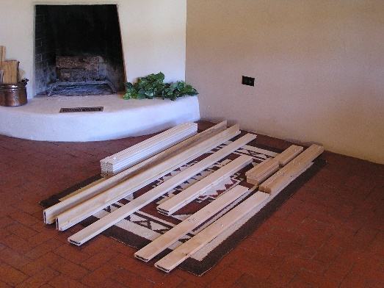
Nomad Furniture Bed Assembly Instructions
Picture 1.
Step 1: Take parts out of the box. All assembly should be on a rug or carpet to prevent scratching the wood as you assemble. Identify the parts. In this picture we have from left to right: slats, rails, center support, drilled crosspieces, slotted crosspieces and headboard slats, and legs.
You will need a #2 Phillips screw driver and a rubber mallet, or hammer with a block of wood (in box,) to prevent denting. A friend is handy!
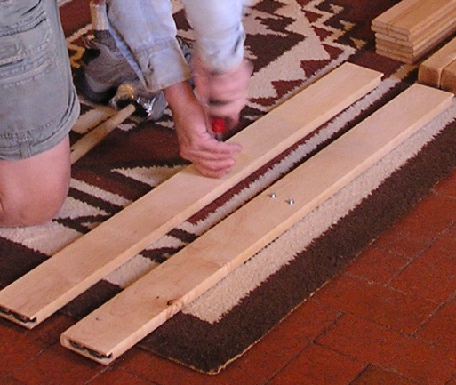
Picture 2.
Step 2: Install 4 5/8" shoulder screws in headboard and footboard drilled crosspieces. These shoulder screws will support the center support.

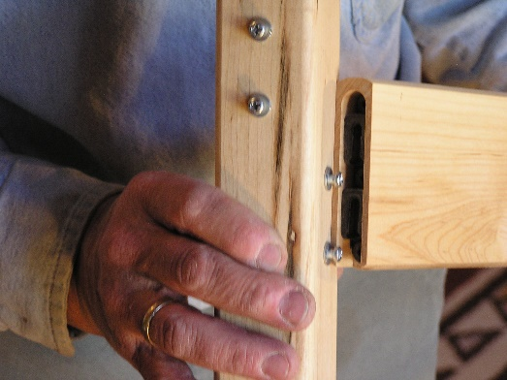
Picture 3.
Important: The lower set of screws on the legs attach to the crosspieces, the higher set of screws attach to the side rails. The ends of the crosspieces and rails are tapped down over the screws.
Notice the alignment of the shoulder screws to the end metal in the crosspiece. This is the correct starting position of the two parts when assembling. The crosspiece will be pushed down over the pins and tapped down with a mallet
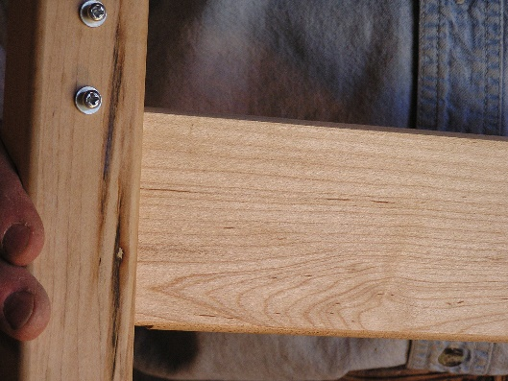
.

Picture 4.
Step 3: Assemble the foot board. Attach the drilled crosspiece to the foot board leg using the lower set of shoulder screws. The shoulder screws on the foot board face inward. Push the crosspiece down over the shoulder screws.

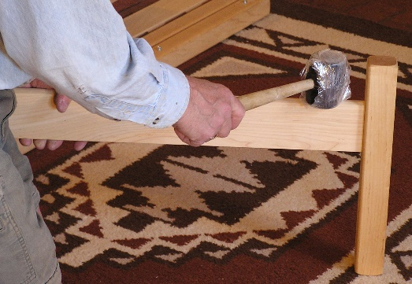
Picture 5.
Step 4: Using a rubber mallet (in a baggie to prevent black marks) tap down crosspiece with firm smacks until snug. If using a hammer we send a block of wood to place on the wood before hammering. This prevents dents in the wood.

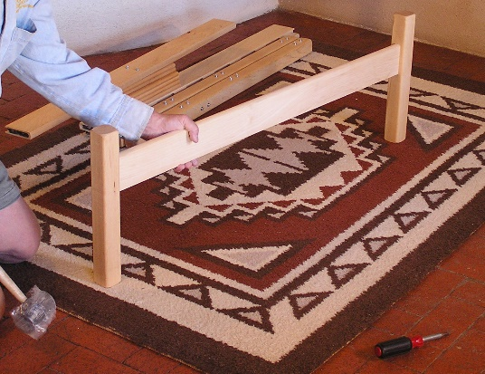
Picture 6.
Step 5: Attach the other foot board leg and tap down snug. The foot board is finished.

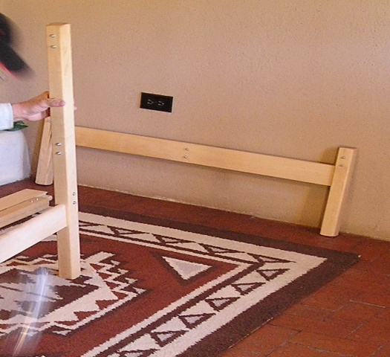
Picture 7.
Step 6: Assemble the head board. Attach the lower crosspiece, with shoulder screws, to the lower set of shoulder screws on one headboard leg. Line up the end of the crosspiece and shoulder screws and tap down snugly.
Set aside this assembly. You will add the other leg after you get the headboard attached to this leg.

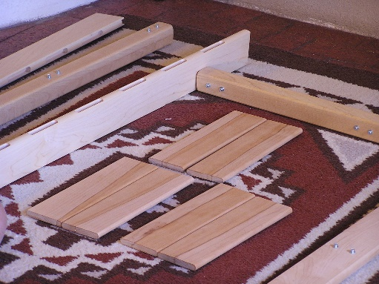
Picture 8.
Step 7: Assembling the mission head board uppers. This assembly is similar to other Nomad bed head boards. The same procedure for the dowels for other head boards.
Lay out parts. Put the slats in order for color and uniformity so appearance is optimized. Prop up slotted crosspiece on edge. Use books or bed parts to hold up crosspiece. A friend is very helpful.
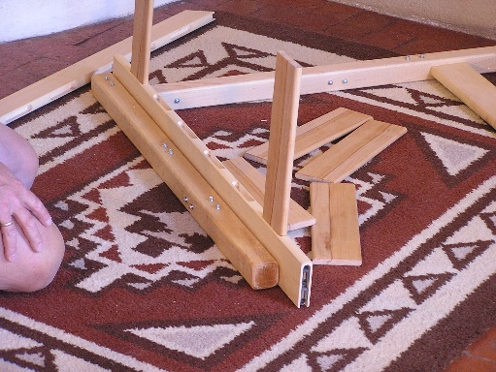
Picture 9.
Step 7: With slotted crosspiece propped up install the head board slats into slots.

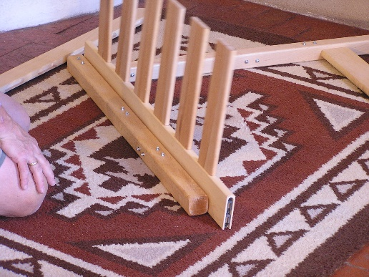
Picture 10.
All slats are in head board lower slotted crosspiece.

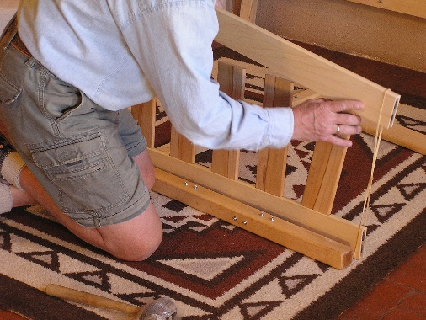
Picture 11.
Step 8: This step can be done with the parts upright (as in photo) or laid down on the carpet. Put rubber band over the ends of both the lower and upper slotted crosspieces. Starting at one end fit the slats into the upper crosspiece slots. This is a good time for a friend but it can be done by one person.

Picture 12.
The rubber band holds the headboards together as you work across to align the slats into the slots of the upper headboard.

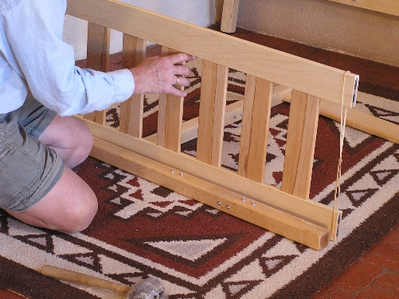
Picture 13.
Step 9: Lay down the completed slat structure. Use alignment stick provided to support the end of the slat structure. Align the ends of crosspieces with the shoulder screws.

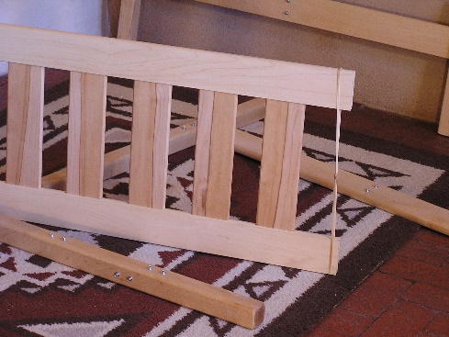
Picture 14.
Push ends of crosspieces down over the leg screws. Tap down the top crosspiece only. Snug up later. Remove rubber-band.

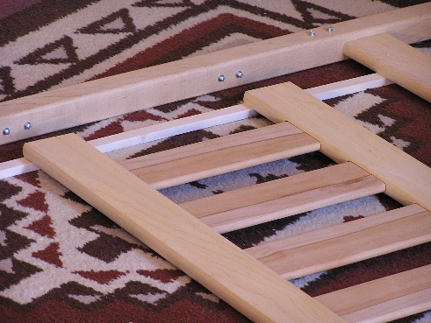
Picture 15.
Step 10: Use alignment stick with parts flat on carpet. Line up all three crosspiece ends with the shoulder screws on other head board leg. Attach all crosspieces at the same time. Use alignment stick to hold crosspiece ends in place while lining up.

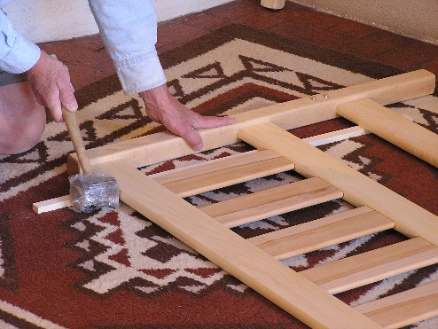
Picture 16.
Step 11: Stand up head board unit. Tap down lower drilled crosspiece until snug.

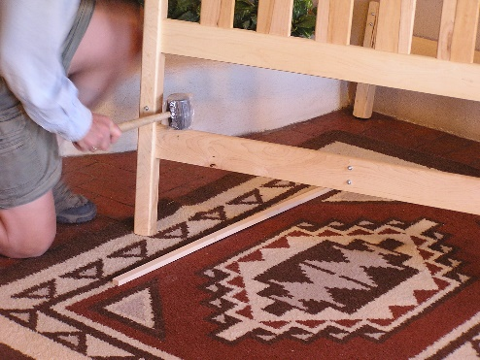
Picture 17.
Tap down top slotted crosspiece until snug at both ends. All head and foot board joints should now be tapped down snug. Stand up headboard unit and tap down on all connections.

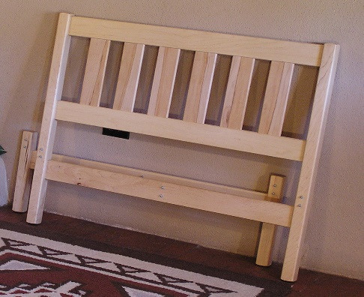

Picture 18.
Lean up head board unit against wall.

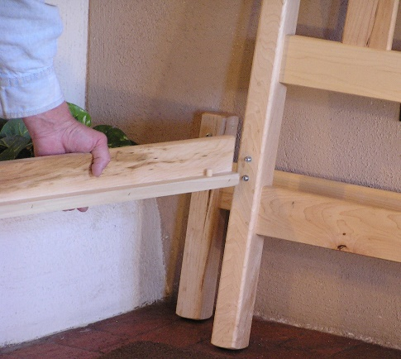
Picture 19.
Step 12: Align side rail with shoulder screws on head board leg. Remember the top shoulder screw starts in the middle of the rail end. Be careful to get the screw properly located before tapping down.

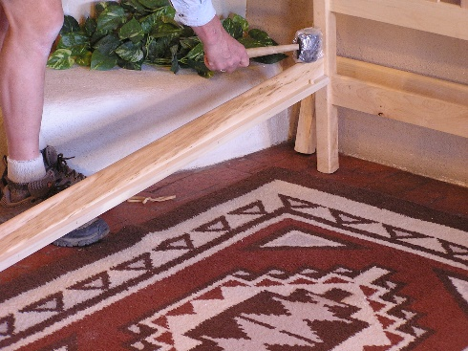

Picture 20.
Tap down side rail until snug. Make sure your ledger strip is on the inside so the slats can rest on it.

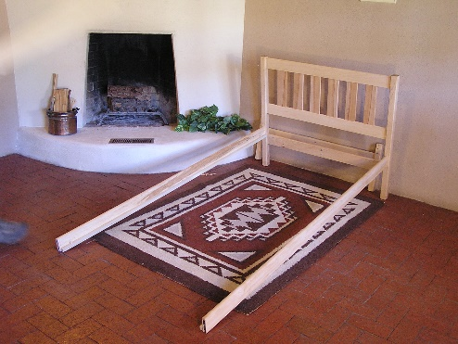
Picture 21.
Attach other side rail and tap down snug.

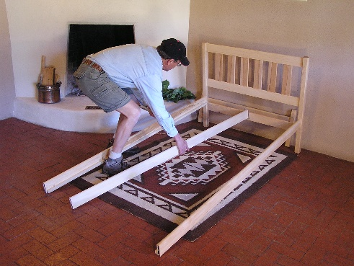
Picture 22.
Loosely attach center support.

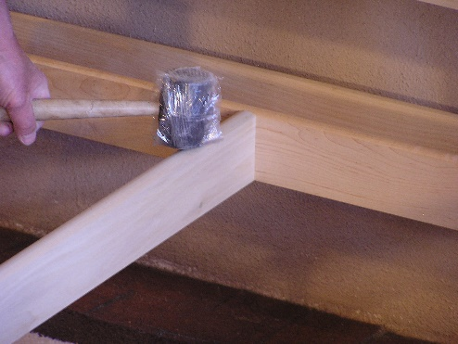

Picture 23.
Now secure the center rail on the headboard crosspiece.

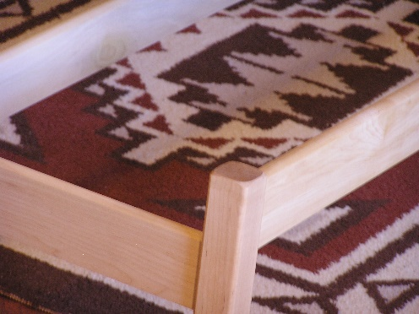
Side-rail
Picture 24.
Foot-board
Notice the alignment of the side rail (right side) and the foot crosspiece (lower board).

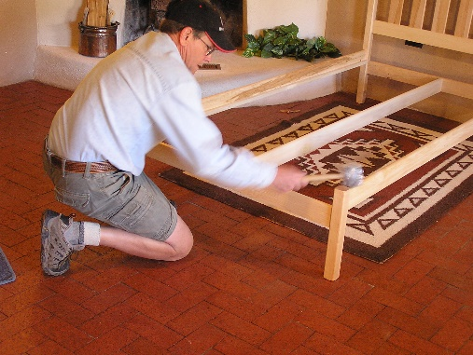

Picture 25.
Step 13: Put foot board in place and line up one rail to foot board leg. Attach and tap down snug. Line up other rail to other foot board leg and tap down snug.

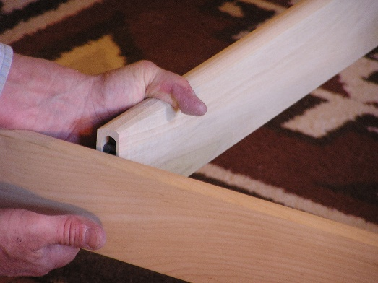
Picture 26.
Step 14: Line up center support to shoulder screws in foot board crosspiece. This will be tight. Use one hand to push the center support back while pulling the foot board crosspiece forward. Then you can align the parts correctly.

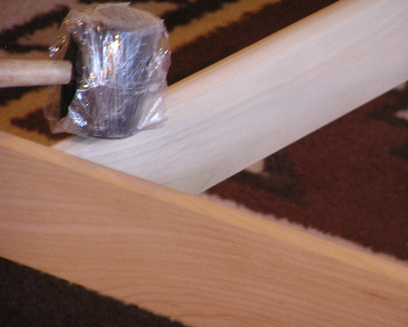

Picture 27.
Tap center support down snug.

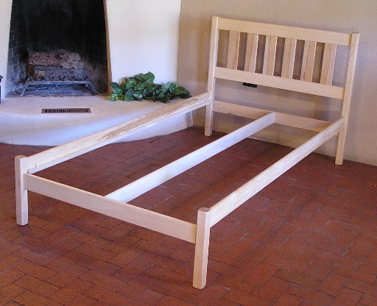
Picture 28.
Pat yourself on the back, sit back and admire your work.

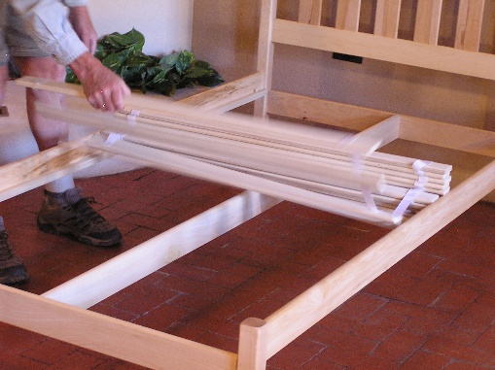
Picture 29.
Step 14: Place the slats on the bed frame and stretch them out. The straps should be on top.

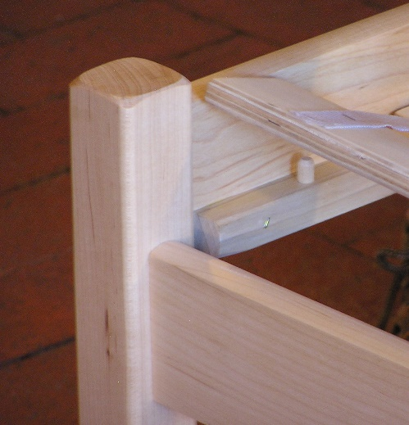
Picture 30.
The last slat will be held in place by the dowel pins in the side rails. Both end slats will be held in place and will stretch out the slats on the frame. These dowel pins should be installed by you after the bed frame is assembled.

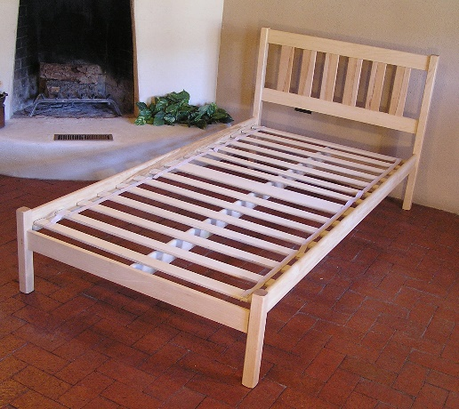
Picture 31.
Looking good!

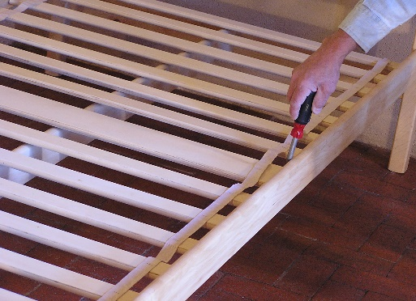
Picture 32.
Pull the middle slat tight against the side rail. Use the two 1" screws to screw down the slat to the side rail. Go to the other side and repeat this step.

Congratulations! You have assembled your bed. Now place your mattress on the bed.

